2026 Request for Recognitions
Remit 2 weeks prior to event to: SHOP@NCCOASTALPINES.ORG / PH: 1-800-284-4475
County/Area:
Requested By:
Telephone:
Email:
Pickup Location (circle): Raleigh Goldsboro Fayetteville Wilmington
Recognition Item |  | Award Information | Item # | Unit Price | Qty Ordered | Total Price
Mainstay Award (Limit 1 w/Certificate & Sterling Silver Anchor Pin | 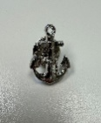  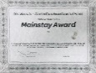 | Recognizes any Girl Scout adult member’s exemplary achievements towards council goals and objectives in the county/area.  Eligible candidates have made significant achievements toward council goals and objectives in a county/area for 5+ years or have contributed to their entire county/area and the growth and development of girls. | 367731955950160 | $28.00
GSUSA Volunteer of Excellence Award | 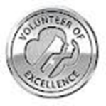 | Recognizes those volunteers who have contributed outstanding service while partnering directly with girls in any activity or program to implement the Girl Scout Leadership Experience. Eligible candidates: must be a registered member, completed full term of service, has performed beyond the expectations for the position to deliver GSLE using the national program portfolio or has supported the council’s mission-delivery goals | 731955090593 | $ 7.20
Valuable Volunteer Award Patch | 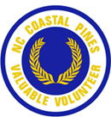 | Recognizes any area or service unit team member who has provided satisfactory service and leadership to the council and the Girl Scout Movement. Eligible candidates must be a registered member who has served one service year in service unit team position. | 367731955050040 | $1.50
Leader Achievement Award Pin | 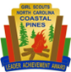 | Recognizes exemplary service of troop co-leaders. Eligible candidates must be a registered member who has completed 2 years of service as a troop co-leader, completed FA/CPR training, completed outdoor skills training, shown proficiency in the Girl Scout Leadership Experience, participated in cookie sale, and completed 1 troop service project; promptly presents awards to girls | 367731955950050 | $2.00
Juliette "Daisy Low" Honor Pin |  | Recognizes any area or service unit members who have provided outstanding leadership and service to the council and the Girl Scout Movement. Eligible candidates must be a registered member who has served in a leadership role 5+ consecutive years and strives to enhance volunteer development. | 367731955950060 | $2.00
New Leader Award Patch | 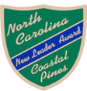 | Recognizes all new Girl Scout co-leaders. Eligible candidates must be a registered member who has completed one year of service as co-leader, completed Volunteer Essentials training, and participate in fall product or cookie sale. | 367731955950070 | $2.00
Diversity, Equity, & Inclusion Award Pin |  | Significantly promotes Diversity, Equity, and Inclusion as cultural competency developments in their area. Addresses key areas of DEI in recruitment, retention, and alternative program delivery in their local area. Maximizes potential of all people by fostering diversity in troops and events in their area. Who to consider registered adult members; community groups and sponsors | 3677319552021 | $2.80
Years of Service Pin (Adult Years)  5 yr Ad Pin  10 yr Ad Pin  15 yr Ad Pin  20 yr Ad Pin  25+ year Free of Charge  Other (indicate years): | 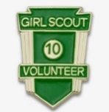 | Recognizes total adult years as a volunteer with active service to Girl Scouting.  Eligible candidates:  • Must be a registered member  • Available in 5 year increments | 731955099732  731955099749  731955099756  731955099763  731955099770 | $4.30  $4.30  $4.30  $4.30  FREE  FREE
Numeral Guards (Girl & Adult Years)  5 year guard  10 year guard  15 year guard  20 year guard  25+ year Free of Charge  Other (indicate years): | 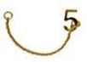 | Recognizes total girl and adult years in Girl Scouting.  Eligible candidates:  • Must be a registered member  • Available in 5 year increments | 731955096090  731955096106  731955096151  731955096205  731955096250 | $2.50  $2.50  $2.50  $2.50  $2.50  FREE
 |  | Subtotal
Officer Use Only: |  | Purchase Location: Raleigh Sales Tax +7.25%:
 |  | Goldsboro, Wilmington Fayetteville +6.75%:
Date: |  | Total:

Additional Notes:

